Yr 12 Physics Practical Test Name: _____________

The Magnetic Field Associated With a Long Straight Wire: Time = 1 hour

The following experiment was set up to investigate the factors that affect the magnetic field around a long straight wire.

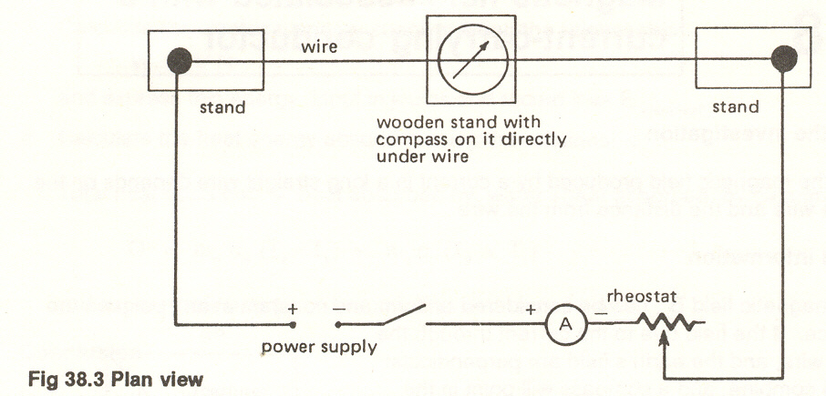
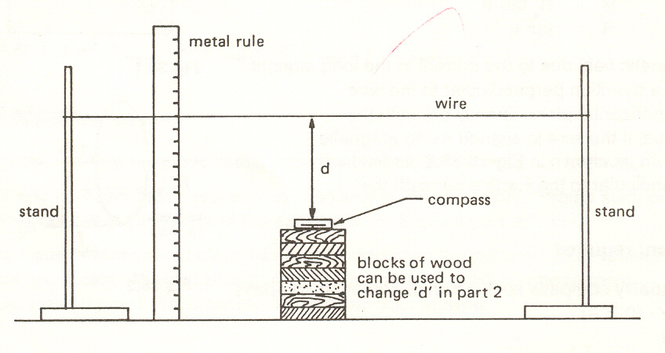

1 Why is the long straight wire set up in a north-south direction?

(1 mark)
2 In the instructions to the experiment it suggested that non ferro-magnetic material be used for the stands and block. Explain why this recommendation was made.

(1 mark)
The following results were obtained when the compass was held at a constant distance from the wire of 15.0 cm and the current varied.

Current (A) | Deflection Right | Deflection Left | Av. Deflection | Tan of Average
5 | 16⁰ | 16⁰ | 16⁰ | 0.287
4 | 12⁰ | 14⁰ | 13⁰ | 0.231
3 | 10⁰ | 10⁰ | 10⁰ | 0.176
2 | 8⁰ | 7⁰ | 7.5⁰ | 0.132
1 | 4⁰ | 4⁰ | 4⁰ | 0.0699

3 Why is the compass deflection on both sides of the wire measured instead of just on one side?
(1 mark)
4 In this experiment, which is the manipulated or independent variable?
(1 mark)
5 Should the manipulated variable be graphed on the x or y axis? (1 mark)
6 Graph the results as appropriate (note that tan Ө does not have units). (3 marks)
7 Calculate the gradient of the line you have obtained. (1 mark)
8 If extended, should the line go through the origin? (1 mark)
9 Explain why. (1 mark)

B_{i} = μ₀I and tan θ = B_{i}
2πd B_{EH}
B_{i} = magnetic field strength around the wire (T) I = the current through the wire (A)
B_{EH} = horizontal component of the Earth’s magnetic field (T) d = distance from the wire (m)
μ₀ = permeability of air = 4π x 10 ⁻⁷ NA⁻² tan θ = tan of the average deflection

10 By combining the two equations obtain an expression for B_{EH} that does not include B_{i}. (2 marks)

11 Using values of μ₀ and d given, and the gradient of the line calculated in question 7, obtain a value for B_{EH} using the equation derived above. (2 marks)

12 In the location that the experiment was carried out the angle of dip to the horizontal was measured at 68.0⁰. Calculate the strength of the earth’s magnetic field at this location. (2 marks)

In another experiment the current was kept constant at 4.0A and the distance between the wire and the compass was varied. The following results were obtained.
Distance (m) | Av. Deflection | Tan Av. Deflection
0.335 | 8⁰ | 0.141
0.285 | 10⁰ | 0.176
0.246 | 11.5⁰ | 0.203
0.182 | 14⁰ | 0.249
0.125 | 19⁰ | 0.344
0.062 | 30⁰ | 0.577

13 Explain what you would do to the data to obtain a straight line graph. Use the equation in Q 9 to justify why this strategy should give you a straight line (2 marks)

14 Carry out your strategy and place the appropriate data in the spare column in the table. (1 mark)

15 Graph your data (2 marks)

16 Determine the gradient of the line. (1 mark)
17 Show how the gradient of the straight line can be used with the equation from question 10 to obtain another value for B_{EH} (Use the values of μ₀ and I that are given) (2 marks)

Total: 25 marks

